**CHAPTER 01**

**INTRODUCTION**

**BlockChain:**

A blockchain is essentially a distributed database of records or public ledger of all transactions or digital events that have been executed and shared among participating parties. Each transaction in the public ledger is verified by consensus of a majority of the participants in the system. And, once entered, information can never be erased. The blockchain contains a certain and verifiable record of every single transaction ever made. The main hypothesis is that the blockchain establishes a system of creating a distributed consensus ​in the digital online world. This allows participating entities to know for certain that a digital event happened by creating an irrefutable record in a public ledger. ​It opens the door for developing a democratic open and scalable digital economy from a centralized one. There are tremendous opportunities in this disruptive technology and revolution in this space. One of these areas that the project tries to explore is the use of BlockChain in the energy sector.

**CHAPTER 02**

**BACKGROUND**

There have already been strides made in the use of BlockChain in the Energy Sector. Marubeni is a Japanese power utility rolling out bitcoin payments for

electric customers. They expect One million bitcoin-paying electric customers expected in 2019. They plan later to include bitcoin payments for gas, water and

mobile phone bills. It could enable customer savings of up to 4%–6%. Bankymoon is a South African producer of bitcoin-addressed smart meters. When a customer sends a bitcoin payment, tariff automatically calculated and meter loaded. Users can send electricity, water and gas to anybody in the world, from anywhere. There has been a rise of the Prosumer, where in the consumer may also be able to produce the energy that it requires. In such cases a BlockChain application to keep track of the energy that was sent back to the grid, that was taken from the grid can be a massive asset to the producers and the consumers alike. Seeing such developments in the field of BlockChain in Energy, the project attempts to simulate an environment where in transfer of Energy and Funds occur using the Ethereum BlockChain network.

**CHAPTER 03**

**PROBLEM DEFINITION AND SCOPE**

The project aims to implement a system that enables transfer of energy and funds between different entities. The entities are the Producers, Providers and Consumers. The flow of energy starts from the Producer, transferred to the Provider and then to the Consumer. After which it is consumed by the Consumer. Along every step of this process, funds are transferred to the respective body for their service.

**CHAPTER 04**

**PROJECT PLAN**

The project defines the different entities as structures. Thus, the Producer, the Provider and the Consumer have their own structure with their independent properties. Each entity has an account to keep a tab on the funds they have remaining and the energy that they have in their storage. This account balance can be checked by the owner of the account. Every time that there is a transaction between these entities, it will be recorded on the BlockChain. Along with the transactions, the energy production and the energy consumption are kept a track of on the BlockChain.

**CHAPTER 05**

**DETAILED DESIGN**

**Structure of Producer:**

The producer has its own address, name, production capacity and a cost per unit at which the producer transfers energy to the provider. The producer’s address will also have an account associated with for the funds that the producer has received. These properties are unique to a producer.

**Structure of Provider:**

The provider has its own address, name, storage capacity and a cost per unit. Since the provider has a storage capacity, the address of the provider will be associated with an account to for the balance of energy after transactions from the producer and to the consumer. Along with this, it shall also have an account for the funds that will reduce on receiving energy from the producer and increase on transferring it to the consumer.

**Structure of Consumer:**

The consumer has its own address, name and storage capacity. Like the provider, the consumer also has an account for the storage of energy and an account for the funds to be transferred to the provider.

**CHAPTER 06**

**IMPLEMENTATION AND RESULT**

In the project, the energy can be only produced by the producer. This energy produced by the producer can only be transferred to the provider. The provider can transfer this energy only to the consumer. The provider may choose to store some of the energy that it receives and send the rest to the consumer. Thus, the route for energy flow have been set. Once energy is obtained by the consumer, the consumer may choose to consume the energy or store it. A required condition for the energy transfer is that the energy that is to be transferred has to be within the storage capacity of the receiver. Also, the receiver must have enough funds to pay to the sender of the energy. On receiving the energy, funds are automatically transferred from the energy receiver to the energy sender. The cost of the energy transfer is obtained as Cost per Unit * Number of Units.

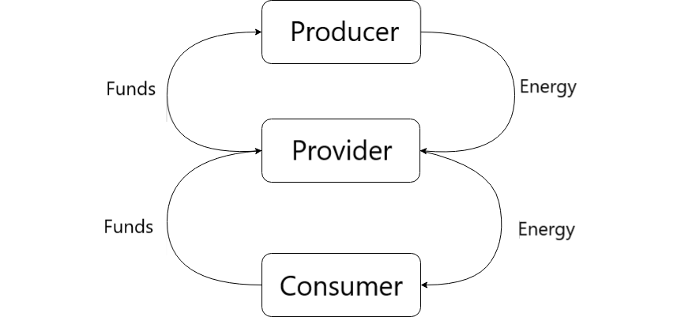

A structure to keep track of the energy creation, transaction and consumption. Thus anytime either of the above mentioned activities takes place, it gets written to the BlockChain.

**Tools Used:**

Remix IDE.

Solidity programming language.

**CHAPTER 07**

**CONCLUSION AND FUTURE ENHANCEMENT**

Thus, we were able to simulate a SmartGrid environment using Solidity. Every transaction of energy and funds, production of energy and the consumption is written to the BlockChain. Information regarding a particular transaction could be obtained using the transaction key.

**Future Enhancement:**

We look forward to enhancing this project by adding a GUI. We can add sophisticated logic and make the project work more efficiently. Currently the project doesn’t take into consideration that the consumer may also have the ability to produce its own energy. As a future enhancement, modifying the consumer to be a prosumer would be a valuable addition.

**Bibliography**

1. PwC global power & utilities, “Blockchain – an opportunity for energy producers and consumers" March 2016.
2. “Building the decentralized utility on the Ethereum BlockChain” Ecosummit Berlin 2016.
3. “EY Global BlockChain Summit” April 26, 2017.